**דוח מעבדה 3**

**שמות מגישים:**

סער ויקטור – 312392822

אילון בן סימון – 312162951

**תרגיל 1**

קוד התכנית:

#include<stdio.h>

#include<stdlib.h>

#include<conio.h>

//define structure

typedef struct Person

{

char ID[10];

char F_name[11];

char L_name[16];

int Age;

char Addr[51];

}Person;

void Error_Msg(char*);

int main()

{

Person temp;

FILE *in, *out;

in = fopen("the_first.txt", "rt");//open file for read "the_first.txt"

if (in == NULL)//check if the open was successful

{

Error_Msg("Error in opening input file");/* Handle case where couldn't open file. */

}

out = fopen("the_second.txt", "wt");//open file for write "the_second.txt"

if (out == NULL)//check if the open was successful

{

Error_Msg("Error in opening output file");/* Handle case where couldn't open file. */

}

fscanf(in, "%s %s %s %d %s", (temp.ID), (temp.F_name), (temp.L_name), &(temp.Age), (temp.Addr));//scan for variables from "the_first.txt"

fprintf(out, "ID:%s\nFull name:%s %s\nAge:%d\nAddress:%s\n", (temp.ID), (temp.F_name), (temp.L_name), (temp.Age), (temp.Addr));//print variables to "the_second.txt"

fclose(in);

fclose(out);

getch();

return 0;

}

void Error_Msg(char* msg)

{

printf("error\n%s", msg);

exit(1);

}

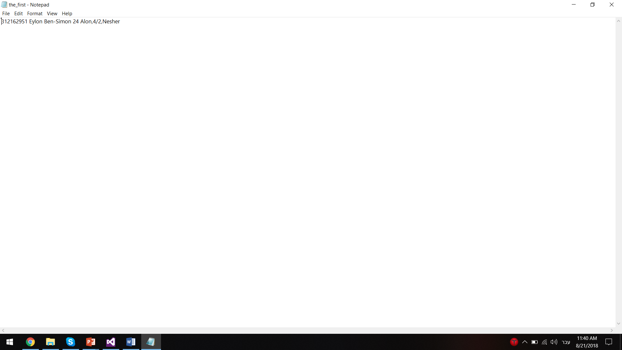פלט (לפני שינוי):

פלט (לאחר שינוי):



**תרגיל 2**

קוד התכנית:

#include<stdio.h>

#include<stdlib.h>

#include<conio.h>

//define structure

typedef struct

{

char name[20];

int grades[3];

}student;

//declertion function

void Error_Msg(char*);

int InputData(student **, FILE*);

void OutputData(int, student*, FILE*);

int main()

{

FILE *fp;

student * arr;

int size;

if (!(fp = fopen("Students.txt", "rt")))//open and check the file for read "Students.txt"

Error_Msg("The input file is wrong");

size = InputData(&arr, fp);

fclose(fp);

if (!(fp = fopen("Students.txt", "wt")))//open and check the file for write "Students.txt"

Error_Msg("The output file is wrong");

OutputData(size, arr, fp);

fclose(fp);

free(arr);

getch();

return 0;

}

int InputData(student ** p_array, FILE * fp)//the function scan and build array of structures from type of student* and return the number of students

{

student *arr;

int i = 1;

arr = (student*)malloc(sizeof(student));

if (arr == NULL)

{

printf("Erorr! memory not allocated");

exit(0);

}

while (fscanf(fp, "%s %d %d %d", arr[i - 1].name, &arr[i - 1].grades[0], &arr[i - 1].grades[1], &arr[i - 1].grades[2]) != EOF)

{

arr = (student*)realloc(arr, sizeof(student)*(i+1));

if (arr == NULL)

{

printf("Erorr! memory not allocated");

exit(0);

}

i++;

}

*p_array = arr;//p_array is pointer to the array in the main

return i - 1; /*return the number of students*/

}

void OutputData(int arr_size, student *arr, FILE* fp)//the function print to the file the max grade of each student

{

int i,max,j;

for (i = 0; i < arr_size; i++)

{

max = arr[i].grades[0];

for (j = 1; j < 3; j++)

{

if (arr[i].grades[j] > max)

max = arr[i].grades[j];

}

fprintf(fp, "name:%s max-grade:%d\n", arr[i].name, max);

}

}

void Error_Msg(char* msg)

{

printf("\n%s", msg);

exit(1);

}

פלט (לפני שינוי):

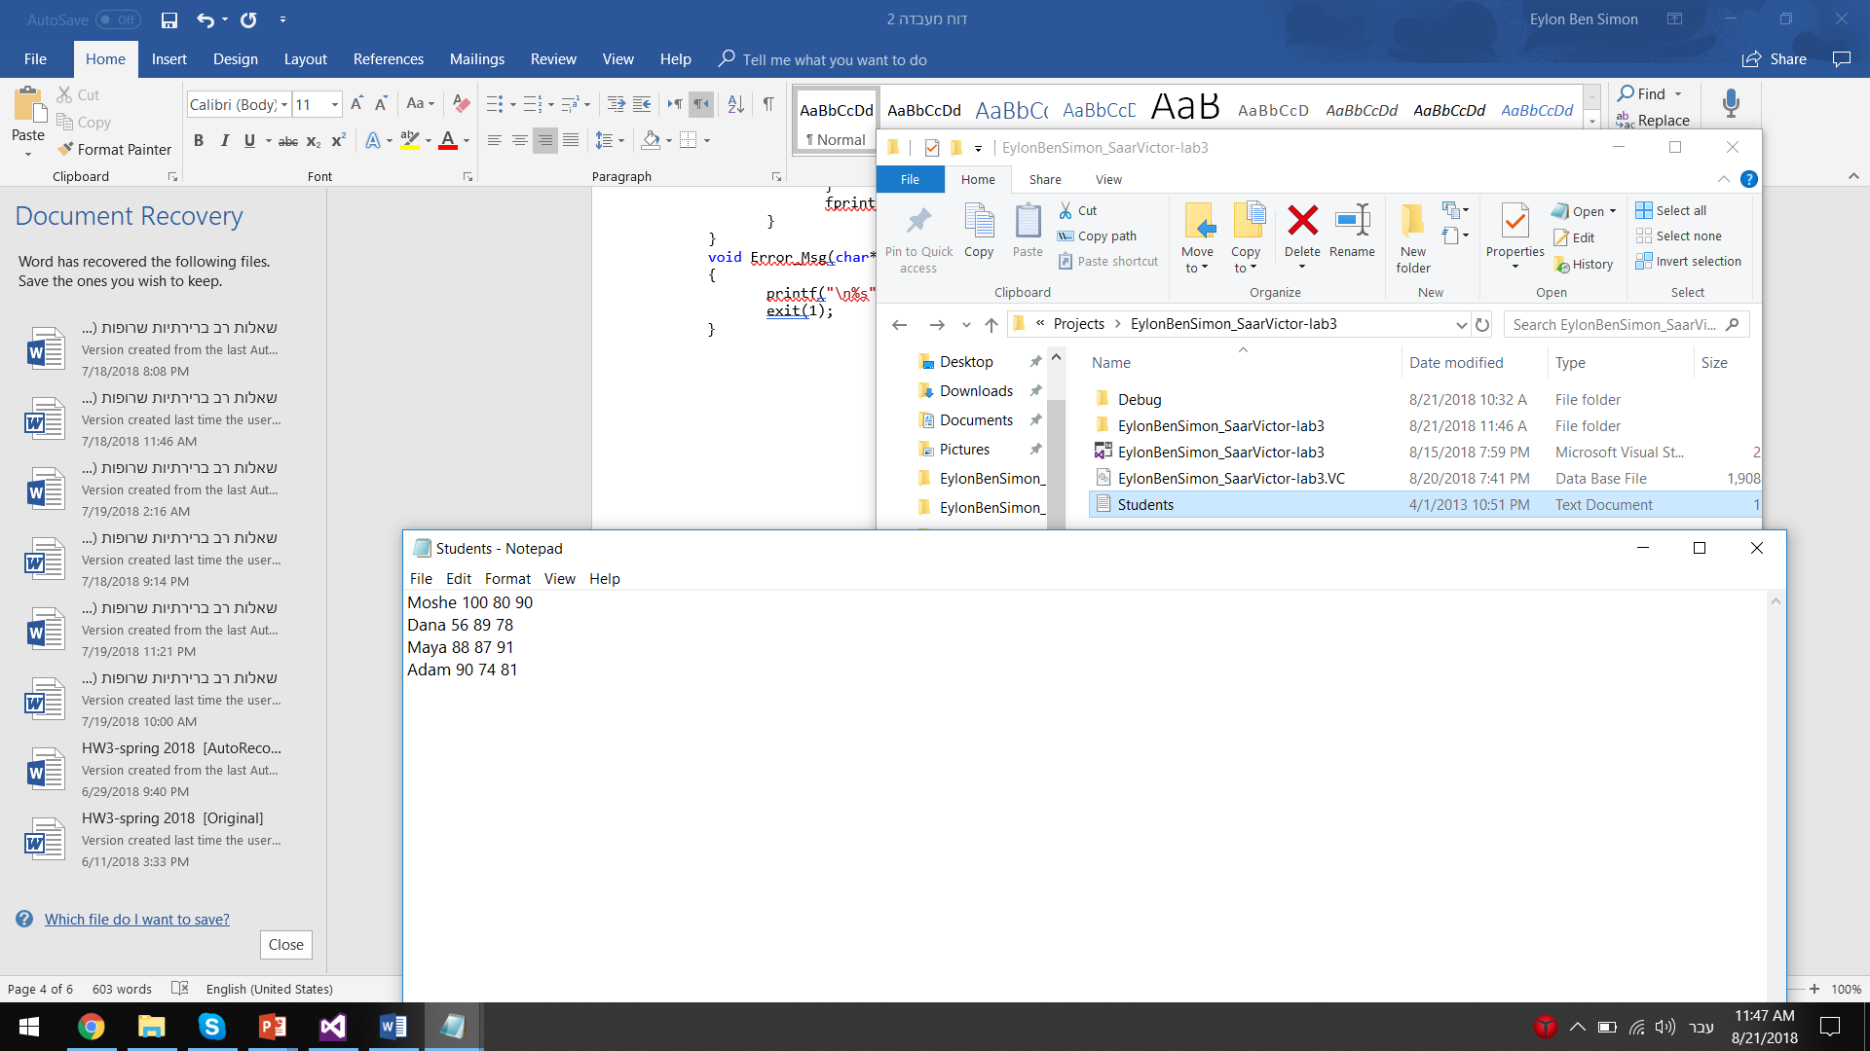

פלט (אחרי שינוי):

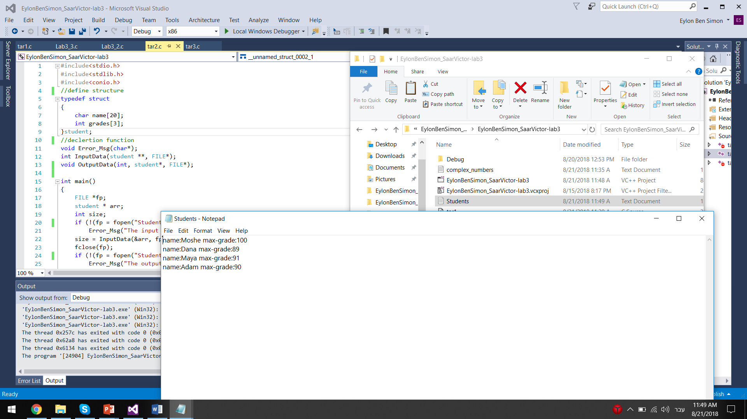

**תרגיל 3**

קוד התכנית:

#include<stdio.h>

#include<stdlib.h>

#include<math.h>

#define N 4

typedef struct Complex//structure definition, complex numbers type (x+yi)

{

float real, img;

}Complex;

//declertion functions

float CRadius(Complex);

void Error_Msg(char* str);

void InputAndWriteToFile(FILE *f);

int CheckFile(FILE *f, float m);

int main()

{

FILE *f;

if (!(f = fopen("complex_numbers.txt", "wt")))//open and check the file for write "complex_numbers.txt"

Error_Msg("The output file is wrong");

InputAndWriteToFile(f);

fclose(f);

if (!(f = fopen("complex_numbers.txt", "rt")))//open and check the file for read "complex_numbers.txt"

Error_Msg("The output file is wrong");

printf("\nThere are %d big numbers\n", CheckFile(f, 4));

fclose(f);

getch();

return 0;

}

void Error_Msg(char* str)

{

printf("\n%s", str);

exit(1);

}

float CRadius(Complex a)//a function that calculates the size of the radius

{

float radius;

radius = sqrt(pow(a.real, 2) + pow(a.img, 2));

return radius;

}

void InputAndWriteToFile(FILE *f)//the function scan from the user complex numbers, calculate the radius of each complex number and print to the file

{

int i;

Complex arr[N];

printf("Enter 4 complex numbers\n");

for(i=0;i<N;i++)

{

scanf("%f %f", &arr[i].real, &arr[i].img);

fprintf(f, "%.1f %.1f %.1f\n", arr[i].real, arr[i].img,CRadius(arr[i]));

}

}

int CheckFile(FILE *f, float m)//the function checks how many radiuses are bigger then m and returns the number

{

int count = 0, i;

float temp;

for (i = 0; i < N; i++)

{

fscanf(f, "%f %f %f", &temp,&temp,&temp);

if ( temp > m)

count++;

}

return count;

}

פלט לדוגמא:

